JAVA PLAYERS ON A TEAM PROJECT AND LAB REPORT
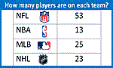
Name and Student ID: Jibran Akhter - 1073973
Date project completed: 02/25/2024
Platform (Mac, PC, Linux, etc.): Windows 11
Development system (onlineGDB, Eclipse, NetBeans): onlineGDB
NOTE: Make a guess at the estimated time BEFORE you even start the project.
Estimated time to complete: 1 hour
Actual time for this project: 1 hour 5 minutes
OBJECTIVES
Use if...else if...else statements to compare numeric values

PROJECT DESCRIPTION
Different sports allow a different number of active players allowed on each team. For example, the NFL (American football) allows 53, the NBA (basketball) allows 13, MLB (baseball) allows 25 and NHL (hockey) allows 23. Design a C or C++ program that does the following: The program first displays a title on the screen and then asks the user to select a team sport. Based on the user's selection the program determines the number of players allowed on the team. The program then asks the user to enter the number players trying to get on the team.
If the number of players trying to get on the team is less than the number permitted on the team, the program will display, "There are not enough players", "nn more players are needed " (where nn is the number needed).
If the number of players trying to get on the team is greater than the number of players permitted, the program will display, "There are too many players, nn players need to be eliminated".
If the number of players trying to get on the team is equal to the number of players permitted, the program will display, "You have the correct number of players".

INPUT – PROCESS – OUTPUT TABLE
INPUTS | PROCESSING | OUTPUTS
teamSport  playersOnTeam | Select team sport from keyboard  Determine teamSize from the team sport  Read playersOnTeam from the keyboard  If playersOnTeam < teamSize Then  Display "There are not enough players" Compute how many more players are needed  Display "# more players are needed"  Else if playersOnTeam > teamSize  Display “There are too many players"  Compute how many more players need to be cut  Display "# players need to be eliminated"  Else  Display “You have the correct number of players” | Number of players needed to be added, removed, or indicate that the number is correct

TEST DATA TABLE
Fill in the Test Data Values and Expected Results as shown on the lab assignment from below.
Choose your sport Just Right To Low Too High
Baseball 25 10 27
Football 53 50 57
Basketball 13 11 17
Hockey 23 20 25
Lacrosse 12 11 13
Identify which sport you are choosing.
Fill in the Actual Results after you have run and tested your program
Which sport?  Football | TEST VALUES  Players who want on the team | EXPECTED RESULT  Computed values before the program is run | ACTUAL RESULT  Enter the message displayed by the program
Too Low | 50 | 3 more are needed | 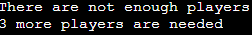
Too High | 57 | 4 players need to be removed | 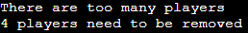
Just Right | 53 | Perfect number of players
Enter something other than 1, 2, 3 or 4 for the team sport selection | 5 | Please enter a valid choice | 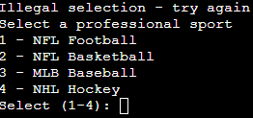
Type letters for number  of players on the team | a | There is an exception in your program | 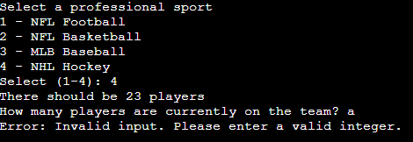

DISCUSSION
What did you do to develop the program? ("Followed the Directions" is not a complete description)
I wrote the given java code using simple commands to achieve each step, such as using if-else statements to handle different sport selections and user inputs, and incorporating a loop to ensure a valid sport selection.

What problems did you have and how did you overcome the problems?

My first systematic problem was that I was unable to incorporate the package at the start of the program but it did not seem to affect my program. After executing multiple output values I noticed that entering alphabets gives an error that is related to exceptional handling.

SCREENSHOTS
Four screenshots are required for this lab report. The types of screenshots are listed below.

Capture only the portion of the screen that shows the calculator or program output. Do not capture the entire screen even though it may also contain the program output. If I need to zoom in on a screenshot, sometimes the image resolution is so poor that I am not able to read it. If this happens, I will ask that you resubmit your lab report. Refer to these instructions capturing screenshots and pasting them to the lab report.


For the Mac
- hold down command + shift keys and press the 4 key
to get a screenshot of a selected area of the screen

- Use the mouse or touchpad to select the desired area of the screen you want to save
- use command + V to paste into the lab report

For Windows

- use Microsoft's Snipping Tool by holding down the
Windows and Shift keys and tapping the ‘S’ key

- Use the mouse or keypad to select the part of the screen you want to save
- use Ctrl+V to into the lab report

Paste four screenshots here
Screenshot #1 – Too many players on a team

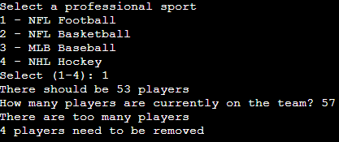

Screenshot #2 – Not enough players on a team

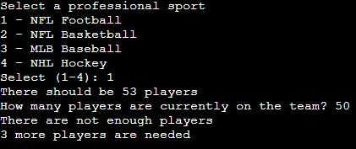

Screenshot #3 – The correct number of players on a team

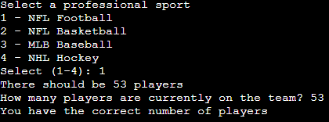

Screenshot #4 – An illegal value for the team sport selection (not 1, 2, 3, or 4)

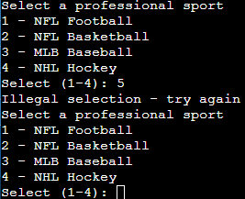

Screenshot #5 – Letters instead of numbers for the players on a team

